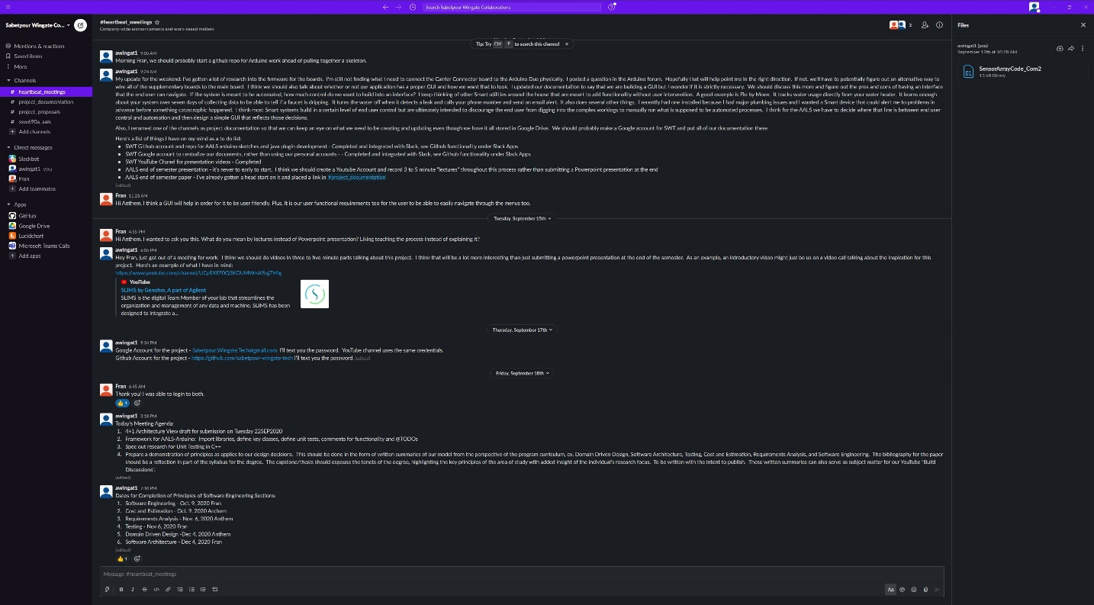
Agility of AALS Development
AALS was developed with the seven principles of lean in mind. Overall, our greatest focus on these principles could be seen in our intention to “Eliminate Waste” and to “See the whole”.
We eliminated waste with each commit. Nonessential code was constantly being cut throughout the our daily or weekly coding cycle. We quickly identified dead ends and halted pursuit of those avenues. As an example, this was particularly relevant as we discovered that adding additional an additional bean for Logging was unnecessary. We eliminated that bean in its entirety and instantiated a class level object in each bean to log exceptions.
Our commitment to see the whole was demonstrated from the inception of the project as we designed each iterative prototype to fit securely in the domain for which it was being designed. From the beginning of this project we were reaching for a fully realized microcontroller specific to the Aeroponics Lab that was being built and not as a generic placeholder for an as yet unrealized laboratory build. As such we saw the whole of the network on which communication between the microcontroller and the database would be conducted and strategically worked to include such considerations in each iteration of development.
In addition, we implemented KanBan practices utilizing our #heartbeat_meetings channel on Slack as a KanBan board. Per Kanban practices, our #heartbeat_meetings Channel allowed us to visualize and manage our workflow while lending careful attention to limiting what in progress activities were being prioritized each week. This tool aided us to further our adherence to lean principles as we sought to eliminate waste. Each week we followed the following steps: set goals, identified those goals as story-based tasks for development, discussed what metrics would define acceptance, proceeded with development, tested for minimal functionality, and finally committed our code as we reached our weekly definition of done.
Our overall approach to development can be characterized under the Dynamic Systems Development Method. It was important, as we followed DSDM, to uphold our focus on frequent, incremental delivery and adherence to an established set of essential criteria of fitness for business purpose as we were acutely aware of timeline and the necessity of that our product would easily meld into the domain for which it was designed. As we keyed in to delivery of iterative prototypes, we carefully more granular detail for our requirements for which we only gathered high-level conceptual ideas to provide an initial base line. In each iteration of development, we were deliberate in our effort to test throughout the product lifecycle lending back to our lean principles and an effort to build quality in at every step of the process.

